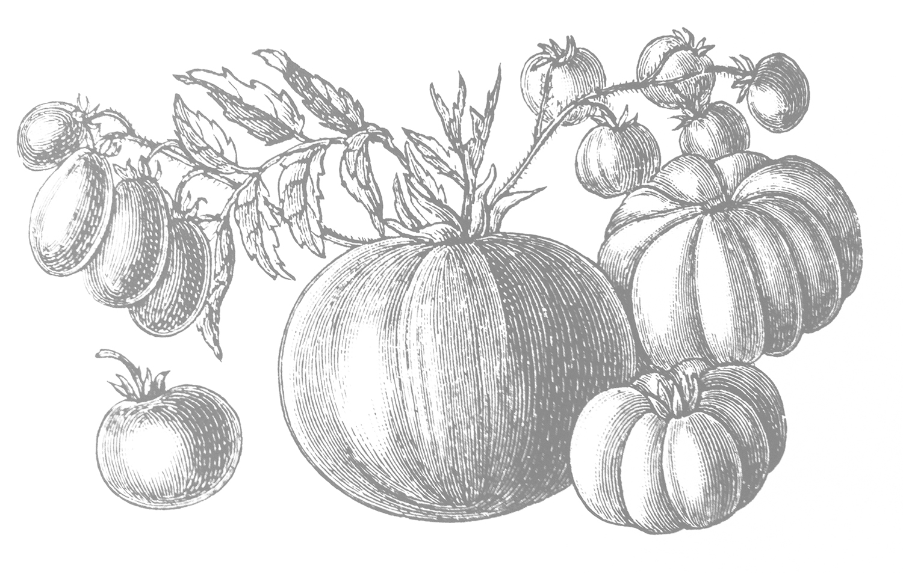

** ­**

**\*Gluten Sensitive**: Centonove is not a gluten-free facility; however, for those menu items indicated, we take great care to avoid direct contact with gluten.

Corkage fee: **15** (max 2 btls) • Outside dessert fee: **2.5/**person   
18% Gratuity added to 6 or more. • We accept Mastercard, Visa and Discover credit cards.

**Owners:** Lisa Rhorer & Pasquale Romano   
**Executive Chef:** Carlo Ochetti

Nobile di Capra, Italy (goat’s milk)

Pecorino Boschetto w/black truffle (sheep/cow)

Pecorino Sardo, Italy (sheep’s milk)

Robiola, Italy (cow/sheep/goat)

Sola di Pecora, Italy (sheep’s milk)

**MEATS & CHEESES AVAILABLE FOR PURCHASE BY THE POUND**

**FORMAGGI / 5 each**

Black-Eyed Susan (raw/sheep’s milk), Royal Oaks, CA

Cacciocavallo, Italy (sheep’s milk)

Dolce Gorgonzola, Italy (cow’s milk)

Fontina Vella, Italy (cow’s milk)

La Tur, Italy (cow/goat/sheep)

**RAVIOLI AL CAVOLO E MASCARPONE**

House-made ravioli stuffed with kale, pine nuts, mascarpone, parmesan, crispy sage, brown butter **14**

**GNOCCHI BICOLORE**

House-made spinach and beet gnocchi, crispy prosciutto, creamy leek sauce **14**

**LINGUINE ALLO SCOGLIO**

Linguine, mussels, clams, shrimp, scallops in a spicy marinara sauce **19**

**GARGANELLI AL POMODORO**

Garganelli pasta, mozzarella fresca, fresh basil and pomodoro sauce baked in wood-fired oven **15**

**PAPPARDELLE AL RAGU DI CINGHIALE**

House-made pappardelle with wild boar ragu **20**

*Gluten-Free Pasta available on request **5**

**ZUPPA DEL GIORNO 6**

**INSALATA DI CAVOLI MISTI**

Organic baby kale, carrots, toasted walnuts, raspberry vinaigrette,   
feta cheese **12**

**INSALATA TRI COLORE**

Arugula, radicchio, endive, roasted pecans with honey-cider vinaigrette **12**

**INSALATA DI SPINACI**

Organic baby spinach, toasted shaved almonds, blueberries, orange segments, lemon vinaigrette **12**

**POLPETTE AL FORNO**

Wood-fired ground beef & veal meatballs with parmesan, garlic, bread crumbs, served with marinara sauce, topped with Fontina cheese **12**

**INSALATA DI PESCE**

Marinated scallop and shrimp salad with lemon juice, mango, served over a bed of baby spinach **14**

**SCAMPI CALABRESE**

Four large wood-fired shrimp, garlic, pepperoncino, EVOO, brandy, basil pesto, fried lemons **16**

**BRUSCHETTA TRICOLORE**

Grilled ciabatta bread, topped with tomatoes, mushroom mousse, pesto, eggplant and goat cheese  **13**

**BURRATA CON PROSCIUTTO CRUDO**

Burrata, black pepper & EVOO served with prosciutto crudo **15**

**CONCHIGLIE Al FORNO (Italian Mac ‘n Cheese)**

Conghiglie pasta, provolone, cheddar, Fontina and Parmesan cheeses, truffle oil and cream, conchiglie pasta baked in the wood-fired oven **13**

**CENTONOVE ANTIPASTI**

Prosciutto crudo, coppa, salami, caponata, marinated artichokes, gorgonzola, grana padano, balsamic-glazed cipollini onions and sundried tomatoes (min 2 people) **17**

**FORMAGGI MISTI**

Choose 3 cheeses served with seasonal accompaniments included **15**

6 Cheeses **25** *see cheeses listed above* **(additional cheeses $5 ea)**

Gluten-free baguette available **5**

**2 for 1 MARGHERITA PIZZAS EVERY SUNDAY**

**HAPPY HOUR • MON-THUR • 5-6PM**

**50% OFF WINES BY THE BOTTLE EVERY TUESDAY**

**Centonove food & wine events: subscribe to our newsletter www.centonovelosgatos.com**

**PIZZA MARGHERITA CENTONOVE**

San Marzano tomatoes, oregano, basil, fresh mozzarella **14**

**PIZZA FUNGHI E FONTINA**

Porcini mushroom, roasted garlic, parsley, thyme, fontina cheese, porcini olive oil **14**

**PIZZA PESCATORE**

Shrimp, scallops, house-made pesto, mozzarella, roasted garlic **19**

**PIZZA PROSCIUTTO CRUDO, ARUGULA E TARTUFO**

Fresh mozzarella, prosciutto crudo, arugula & white truffle oil **15**

**PIZZA DEL MERCATO**

San Marzano tomatoes, grilled zucchini, kalamata olives, artichokes,   
roasted peppers, fresh mozzarella, goat cheese **14**

**PIZZA CINGHIALE**

Wild boar sausage, Mama Lil’s peppers, fried eggplant, mozzarella, pecorino pepato **19**

**PIZZA DEL SALUMIERE**

San Marzano tomatoes, fresh mozzarella, salame, italian ham, coppa, crispy prosciutto, parmesan **17**

Add Calabrese sausage **3** Add Prosciutto **3**

Add Farm egg **2**  Add Mama Lil’s peppers **2**

Add Garlic **1** Add Gluten-free pizza crust **5**

*\*Centonove’s pizzas are created in the Neapolitan style—soft in the center, made to eat with a knife and fork or folded. Please allow   
extra time for Gluten-Free pizzas. Grazie!*

**PETTO DI POLLO AL MATTONE**

10 oz Mary’s air-chilled chicken cooked under brick,   
Calabrian pepperoncino sauce, seasonal greens, sweet potatoes **20**

**SALMONE ALLA GRIGLIA**

7 oz grilled wild salmon, seasonal vegetables, EVOO, lemon and grilled polenta **25**

**FILETTO DI MANZO CENTONOVE**

8 oz grilled beef tenderloin, cipollini onions, balsamic glaze, grilled polenta, asparagus **30**

**CHARCUTERIE (MEATS) / 4 each**

Barolo Salamae, Italy

Coppa Mild Salame, Molinari, San Francisco

Mortadella w/pistachio, Leoncini, Italy

Prosciutto Cotto, Leoncini, Italy

Prosciutto, 18 mth aged, Galloni, Italy

**DINNER**