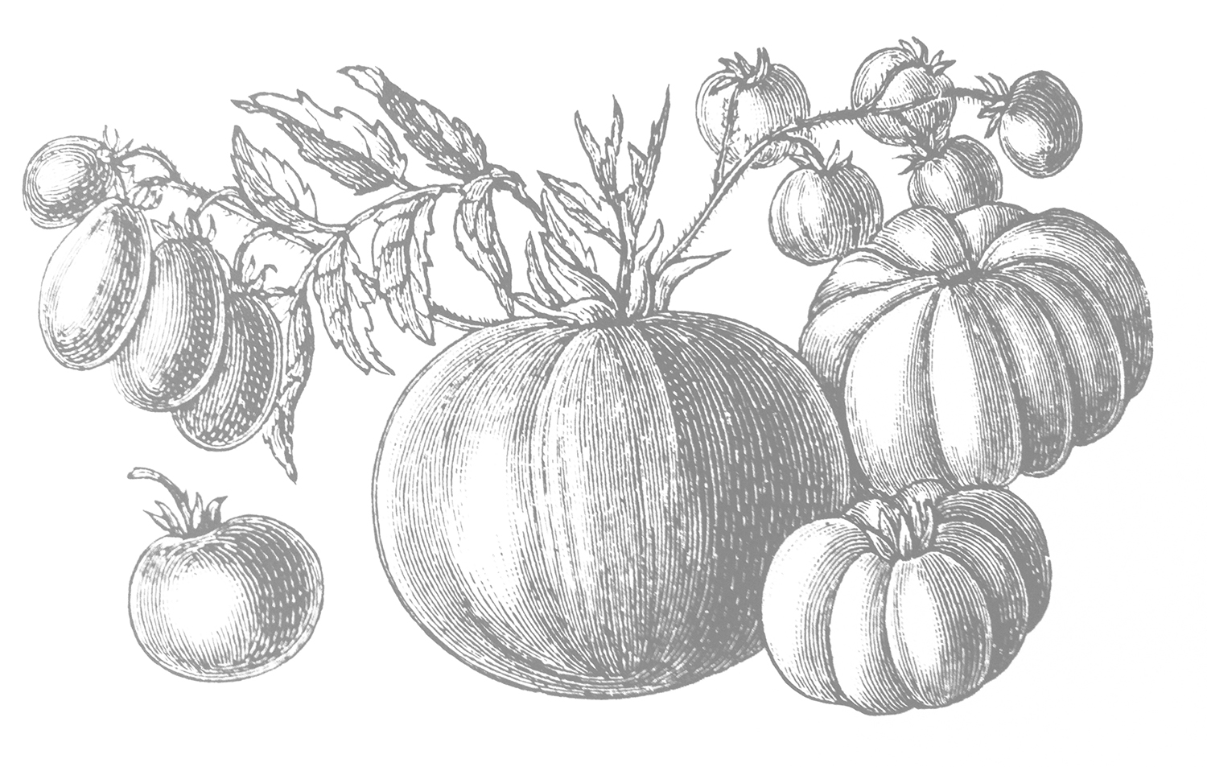

** ­**

*Bread available on request

Gluten-Free Pasta available on request **5**

**\*Gluten Sensitive**: Centonove is not a gluten-free facility; however, for those menu items indicated, we take great care to avoid direct contact with gluten.

Corkage fee: **15** (max 2 btls) • Outside dessert fee: **2.5/**person   
18% Gratuity added to 6 or more.   
We accept Mastercard, Visa and Discover credit cards.

**POLPETTE AL FORNO**

Wood-fired ground beef & veal meatballs with parmesan, garlic, bread crumbs, served with marinara sauce, topped with Fontina cheese **12**

**INSALATA DI PESCE**

Marinated scallop and shrimp salad with lemon juice, mango, served over a bed of baby spinach **14**

**SCAMPI CALABRESE**

Four large wood-fired shrimp, garlic, pepperoncino, EVOO, brandy, basil pesto, fried lemons **16**

**BRUSCHETTA TRICOLORE**

Grilled ciabatta bread, topped with tomatoes, mushroom mousse, pesto, eggplant and goat cheese  **13**

**BURRATA CON PROSCIUTTO CRUDO**

Burrata, black pepper & EVOO served with prosciutto crudo **15**

**CONCHIGLIE Al FORNO (Italian Mac ‘n Cheese)**

Conghiglie pasta, provolone, cheddar, Fontina and Parmesan cheeses, truffle oil and cream, conchiglie pasta baked in the wood-fired oven **13**

**CENTONOVE ANTIPASTI**

Prosciutto crudo, coppa, salami, caponata, marinated artichokes, gorgonzola, grana padano, balsamic-glazed cipollini onions and sundried tomatoes (min 2 people) **17**

**FORMAGGI MISTI**

Choose 3 cheeses served with seasonal accompaniments included **15**

6 Cheeses **25 (additional cheeses $5 ea)**

Gluten-free baguette available **5**

**ZUPPA DEL GIORNO 6**

**INSALATA DI CAVOLI MISTI**

Organic baby kale, carrots, toasted walnuts, raspberry vinaigrette,   
feta cheese **12**

**INSALATA TRI COLORE**

Arugula, radicchio, endive, roasted pecans with honey-cider vinaigrette **12**

**INSALATA DI MANZO**

Grilled 10 oz New York steak organic baby kale, sliced avocado, cherry tomatoes, toasted pine nuts, red onions, lemon-basil vinaigrette **17**

**INSALATA TACCHINO**

Free-range, oven roasted turkey breast honey gem lettuce, gorgonzola dressing, crispy pancetta, hard-boiled egg, shredded carrots **15**

**INSALATA DI TONNO CRUDO**

4 oz sushi-grade sesame seed-crusted Ahi tuna, arugula, red bell pepper, couscous, kalamata olives, lemon vinaigrette **17**

**INSALATA DI SALMONE**

6 oz wild salmon, organic baby spinach, toasted shaved almonds, blueberries, orange segments **16**

**MEATS & CHEESES AVAILABLE FOR PURCHASE BY THE POUND**

Nobile di Capra, Italy (goat’s milk)

Pecorino Boschetto w/black truffle (sheep/cow)

Pecorino Sardo, Italy (sheep’s milk)

Robiola, Italy (cow/sheep/goat)

Sola di Pecora, Italy (sheep’s milk)

**FORMAGGI / 5 each**

Black-Eyed Susan (raw/sheep’s milk), Royal Oaks, CA

Cacciocavallo, Italy (sheep’s milk)

Dolce Gorgonzola, Italy (cow’s milk)

Fontina Vella, Italy (cow’s milk)

La Tur, Italy (cow/goat/sheep)

**Owners:** Lisa Rhorer & Pasquale Romano   
**Executive Chef:** Carlo Ochetti

PIADINA ITALIAN SANDWICHES

Piadina is a thin Italian flatbread, typically prepared in the Romagna region, made with flour, olive oil salt and water.

Served with side salad of baby gem lettuce and lemon vinaigrette **$12**

**CLASSIC ROMAGNA**

Prosciutto crudo, robiola cheese, wild arugula, garlic aioli

**PIADINA DEL NORD OVEST**

smoked salmon, goat cheese, carmelized onions

**PIADINA DEL CASALE**

porchetta, carmelized onions, Mama Lil’s peppers, gruyere cheese

**PIADINA CONTADINA**

zucchini, basil pesto, roasted bell pepper, artichoke hearts, goat cheese

**RAVIOLI AL CAVOLO E MASCARPONE**

House-made ravioli stuffed with kale, pine nuts, mascarpone, parmesan, crispy sage, brown butter **14**

**GNOCCHI BICOLORE**

House-made spinach and beet gnocchi, crispy prosciutto, creamy leek sauce **14**

**LINGUINE ALLO SCOGLIO**

Linguine pasta, mussels, clams, shrimp, scallops in a spicy marinara sauce **19**

**PIZZA MARGHERITA CENTONOVE**

San Marzano tomatoes, oregano, basil, fresh mozzarella **14**

**PIZZA FUNGHI E FONTINA**

Porcini mushroom, roasted garlic, parsley, thyme, fontina cheese, porcini olive oil **14**

**PIZZA PESCATORE**

Shrimp, scallops, house-made pesto, mozzarella, roasted garlic **19**

**PIZZA PROSCIUTTO CRUDO, ARUGULA E TARTUFO**

Fresh mozzarella, prosciutto crudo, arugula & white truffle oil **15**

**PIZZA DEL MERCATO**

San Marzano tomatoes, grilled zucchini, kalamata olives, artichokes,   
roasted peppers, fresh mozzarella, goat cheese **12**

**PIZZA CINGHIALE**

Wild boar sausage, Mama Lil’s peppers, fried eggplant, mozzarella, pecorino pepato **19**

**PIZZA DEL SALUMIERE**

San Marzano tomatoes, fresh mozzarella, salame, italian ham, coppa, crispy prosciutto, parmesan **17**

Add Calabrese sausage **3** Add Prosciutto **3**

Add Farm egg **2**  Add Mama Lil’s peppers **2**

Add Garlic **1** Add Gluten-free pizza crust **5**

*\*Centonove’s pizzas are created in the Neapolitan style—soft in the center, made to eat with a knife and fork or folded. Please allow   
extra time for Gluten-Free pizzas. Grazie!*

**CHARCUTERIE / 4 each**

Barolo Salamae, Italy

Coppa Mild Salame, Molinari, San Francisco

Mortadella w/pistachio, Leoncini, Italy

Prosciutto Cotto, Leoncini, Italy

Prosciutto, 18 mth aged, Galloni, Italy

**LUNCH**